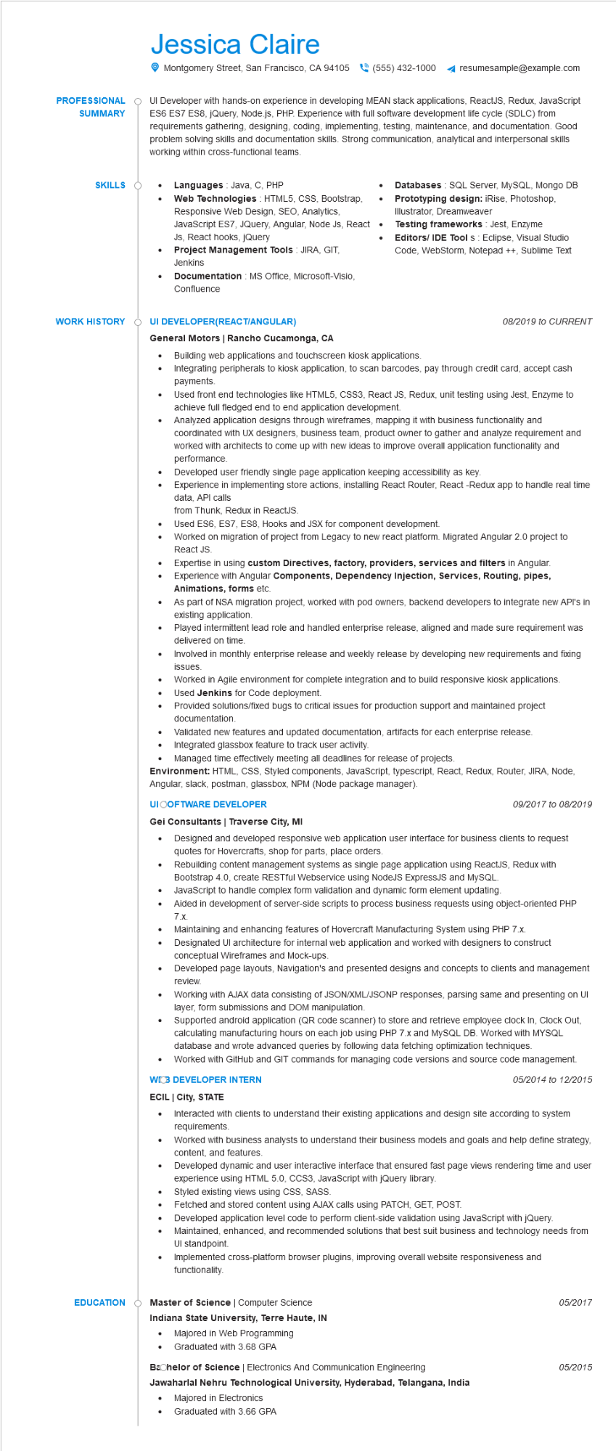
PROFESSIONAL SUMMARY
Jessica Claire
Montgomery Street, San Francisco, CA 94105 (555) 432-1000
resumesample@example.com
UI Developer with hands-on experience in developing MEAN stack applications, ReactJS, Redux, JavaScript ES6 ES7 ES8, jQuery, Node.js, PHP. Experience with full software development life cycle (SDLC) from requirements gathering, designing, coding, implementing, testing, maintenance, and documentation. Good problem solving skills and documentation skills. Strong communication, analytical and interpersonal skills working within cross-functional teams.
SKILLS
•
•
Languages Java, C, PHP
Web Technologies HTML5, CSS, Bootstrap, Responsive Web Design, SEO, Analytics,
JavaScript ES7, JQuery, Angular, Node JS, React
Js, React hooks, jQuery
Project Management Tools: JIRA, GIT,
Jenkins
Documentation: MS Office, Microsoft-Visio, Confluence
•
Databases SQL Server, MySQL, Mongo DB
Prototyping design: iRise, Photoshop,
Illustrator, Dreamweaver
Testing frameworks: Jest, Enzyme
Editors/ IDE Tools: Eclipse, Visual Studio
Code, WebStorm, Notepad++, Sublime Text
WORK HISTORY
UI DEVELOPER(REACT/ANGULAR)
General Motors | Rancho Cucamonga, CA
• Building web applications and touchscreen kiosk applications.
•
08/2019 to CURRENT
Integrating peripherals to kiosk application, to scan barcodes, pay through credit card, accept cash payments.
Used front end technologies like HTML5, CSS3, React JS, Redux, unit testing using Jest, Enzyme to achieve full fledged end to end application development.
Analyzed application designs through wireframes, mapping it with business functionality and coordinated with UX designers, business team, product owner to gather and analyze requirement and worked with architects to come up with new ideas to improve overall application functionality and performance.
Developed user friendly single page application keeping accessibility as key.
Experience in implementing store actions, installing React Router, React -Redux app to handle real time data, API calls
from Thunk, Redux in ReactJS.
Used ES6, ES7, ES8, Hooks and JSX for component development.
Worked on migration of project from Legacy to new react platform. Migrated Angular 2.0 project to React JS.
Expertise in using custom Directives, factory, providers, services and filters in Angular. Experience with Angular Components, Dependency Injection, Services, Routing, pipes, Animations, forms etc.
As part of NSA migration project, worked with pod owners, backend developers to integrate new API's in existing application.
Played intermittent lead role and handled enterprise release, aligned and made sure requirement was delivered on time.
• Involved in monthly enterprise release and weekly release by developing new requirements and fixing issues.
•
•
Worked in Agile environment for complete integration and to build responsive kiosk applications. Used Jenkins for Code deployment.
Provided solutions/fixed bugs to critical issues for production support and maintained project documentation.
.
Validated new features and updated documentation, artifacts for each enterprise release. Integrated glassbox feature to track user activity.
Managed time effectively meeting all deadlines for release of projects.
Environment: HTML, CSS, Styled components, JavaScript, typescript, React, Redux, Router, JIRA, Node, Angular, slack, postman, glassbox, NPM (Node package manager).
UI OOFTWARE DEVELOPER
Gei Consultants | Traverse City, MI
•
09/2017 to 08/2019
Designed and developed responsive web application user interface for business clients to request quotes for Hovercrafts, shop for parts, place orders.
Rebuilding content management systems as single page application using ReactJS, Redux with Bootstrap 4.0, create RESTful Webservice using NodeJS ExpressJS and MySQL.
JavaScript to handle complex form validation and dynamic form element updating.
• Aided in development of server-side scripts to process business requests using object-oriented PHP 7.x.
•
Maintaining and enhancing features of Hovercraft Manufacturing System using PHP 7.x.
Designated Ul architecture for internal web application and worked with designers to construct conceptual Wireframes and Mock-ups.
Developed page layouts, Navigation's and presented designs and concepts to clients and management review.
Working with AJAX data consisting of JSON/XML/JSONP responses, parsing same and presenting on UI layer, form submissions and DOM manipulation.
Supported android application (QR code scanner) to store and retrieve employee clock In, Clock Out, calculating manufacturing hours on each job using PHP 7.x and MySQL DB. Worked with MYSQL database and wrote advanced queries by following data fetching optimization techniques.
Worked with GitHub and GIT commands for managing code versions and source code management. WICB DEVELOPER INTERN
ECIL | City, STATE
•
05/2014 to 12/2015
Interacted with clients to understand their existing applications and design site according to system requirements.
Worked with business analysts to understand their business models and goals and help define strategy, content, and features.
•
Developed dynamic and user interactive interface that ensured fast page views rendering time and user experience using HTML 5.0, CCS3, JavaScript with jQuery library.
Styled existing views using CSS, SASS.
Fetched and stored content using AJAX calls using PATCH, GET, POST.
Developed application level code to perform client-side validation using JavaScript with jQuery.
Maintained, enhanced, and recommended solutions that best suit business and technology needs from Ul standpoint.
Implemented cross-platform browser plugins, improving overall website responsiveness and functionality.
EDUCATION
Master of Science | Computer Science
Indiana State University, Terre Haute, IN
• Majored in Web Programming
05/2017
• Graduated with 3.68 GPA
Bachelor of Science | Electronics And Communication Engineering
05/2015
Jawaharlal Nehru Technological University, Hyderabad, Telangana, India
Majored in Electronics
Graduated with 3.66 GPA

